

Web Solution

Guru.in FRD

SUBMITTED BY

Discover Excellence

Objective & Audience of This Document

This document will cover the functional requirement for the project Guru.in. Audiences of this document are the client business analyst and the project development team.

Revisions History

Revision Version No. | Revised/Prepared By | Date | Refer to Section
1.01 | Ashim Saha | 22/2/2013 | Entire document.
1.02 | Ashim Saha | 23/2/2013 | Entire document.

Table of Contents

Objective & Audience of This Document 2
Revisions History 2
INTRODUCTION 7
1.1 Software & System Overview 7
1.2 Purpose & Scope of This Software 9
1.3 The System Architecture Diagram 10
1.4 Reference 11
1.5 Definition and Abbreviation 11
OVERALL DESCRIPTION 12
2.1 Other Software Feature List 12
2.2 Platform & Technology 12
2.3 Third Party Dependency 12
2.4 R&D Scope 12
SPECIFIC REQUIREMENTS 13
3.1 Software Interface Definition 13
3.2 Other Software Features 13
ER DIAGRAMS 14
#1.0 User profile 14
#2.0 Company profile 15
#3.0 User service 16
#4.0 Company service 16
#5.0 admin user 17
#6.0 Franchisee 19
DATA STORAGE 20
admin_type 20
admin_type_permission 20
admin 20
category 20
sub_category 20
country 20
state 21
city 21
zip 21
popular_location 21
zip_location_mapping 21
option 22
doc_verification 22
theme 22
bulk_mail 22
variables 22
cms 22
reserved_domain_keyword 22
search_cache 23
users 23
user_details 23
user_education 24
user_profession 24
user_certificate 24
user_license 25
user_skill 25
user_public_private_field 25
user_service 25
category_service_extended_defination 26
user_service_extended 26
user_service_quotation 27
user_service_recommendation 27
user_favourite_sevice 27
user_feature_package 28
user_suggestion 28
user_save_search 28
user_report_abuse 28
user_feedback 28
user_reference 28
user_like 29
user_doc_verification 29
user_company 29
user_company_certificate 29
user_company_license 30
user_company_employee 30
franchisee_domain 30
franchisee_theme 30
franchisee_location 31
franchisee_language 31
franchisee_category 31
advertisement 31
ads_campaign 31
domain_variables 32
payment 32
DATA FLOW DIAGRAMS 33
Front Interface Diagrams 33
Home Page 33
HomePop-up 33
Sign Up 33
Login 33
Login Recovery 33
Report Abuse 33
Contact Us 34
Start up Pages 34
Select a Service Type 34
Make Service Featured 34
Make Service Featured_2 34
Start A Company 34
Option for Profile Entry 34
Demo edit mode 35
Add a service 35
Company Profile 35
Company Profile 35
Company Profile After 1st time 36
Service Profile 36
Service Profile 36
Service Profile edit 36
Service Profile Entry 1st time 37
Recomendation 37
User Profile 37
User Profile 37
Ist Time User info entry 37
User Profile edit 38
Be A Franchisee 38
Domain and Sub Domain 38
Select Location 38
Select Category 38
Select Language 39
Upload Logo 39
Select Theme 39
Site Management 39
Listing Profile 39
Listing for Designer 39
Listing For Dentist 40
Listing for Tutor 40
Listing for Maths tutor OR IN CASE OF SPECIALIZATION 40
Listing for US tutor 41
Listing for the keyword math 41
Dashboard 41
Dashboard 41
Inbox 42
Favourite 42
Save Search 42
Endorsement 42
Manage Recommendation 42
Employee List 42

INTRODUCTION

1.1 Software & System Overview

Guru.in will be a website where people come to list their service as individual or company and can find services from other individual or company by keywords, cities, zip codes & area names. It will work like a yellow page. All labels of this site will be multi-lingual; however the content added by the users of the site can be of specific language. It has following features.

Front-end Features:-

Visitors Features:

- Search list of services (provided by individual & company) and filter the result by different criteria (no registration required)

Individual Member Features:

- Register as member
- Registered member can update his/her profile (profile without service added is not search sensitive)
- Profile updated could be verified on submission of required documents and verification fee payment
- Registered member can create max one service as individual under any particular category

Company Member Features:

- Registered member can upgrade his account as company for additional payment (Before upgrading to company account if there was any service that will be part of the company service on company account activation. On non-payment company account will be converted back to individual account and default service of company will be part of the creator’s individual account.)
- Company user can update his company profile
- Company Profile updated could be verified on submission of required documents and verification fee payment
- Company user can create max 5 services as company under various categories and can add service providers to each service. (Service providers are like normal registered member but they cannot opt to detach themselves from company account and cannot create individual service)

Other Registered Member Features:

- Registered member can contact other member through internal messaging system/email forwarding (at this moment email forwarding will be implemented)
- Registered member can save search and can share over internet

Franchisee Features:

- Registered member can apply as Franchisee for redistribution of search result under any category and language and city. They will also share commission in case visitor come and register in the guru through their site.
- On activation as franchisee they will have access to something like admin panel whereby they will be able to manage the franchisee site.

Admin Panel Features:-

Admin Activities

- Login
- Manage Account (change password)
- Manage Admin Account (list, add, edit, delete, disable, set privilege)
- Manage Site Settings (set parameters like – auto approval of expert/guru portfolio, Google Adsense API key, max no. of saved search allowed, max no. of listing service allowed, max no. of expert/guru service allowed, max no. of message a day, minimum redeem amount)
- Manage Site Caches (clear search query cache, clear search suggestion cache)
- Manage Country (list, add, edit, delete)
- Manage State (list, add, edit, delete)
- Manage City (list, add, edit, delete)
- Manage Zip Code (list, add, edit, delete) [this include lat-long info as well]
- Manage Popular Place (list, add, edit, delete)
- Manage Category (tree view - list, add, edit, choose category specific attribute, delete) [ in future features like Forum and Q&A will be available based on category as well ]
- Manage Language (list, add, edit, delete)
- Manage Domains of Interest (list, add, edit, delete)
- Manage New Domains of Interest Suggestion (list, add, edit, delete, approve)
- Manage Company Name (list, add, edit, delete)
- Manage New Company Name Suggestion (list, add, edit, delete, approve)
- Manage Educational Institution (list, add, edit, delete)
- Manage New Educational Institution Suggestion (list, add, edit, delete, approve)
- Manage Member Account (list, view account & profile details, add, edit, delete, disable, add admin note, view report abuse count, mark as not an abuse permanently) [‘mark as not an abuse permanently’ auto reset if that particular user edit his profile]
- Manage Member Profile Feedback (list, view feedback details, disable profile/account)
- Manage Member Account Verification Request (list, view account & profile & document details, accept for processing, set as verified/rejected)
- Manage Company Account (list, view account details, add, edit, delete, disable) (part of future implementation)
- Manage Expert/Guru Service (list, view details, approve/disapprove, set as featured for a specified amount of time, set as featured online a specified amount of time)
- Manage Listing Service (list, view details, edit, approve/disapprove)
- Manage Reserved Keyword for Domain Suffix for Listing Service (list, add, edit, delete)
- Manage Report – Listing Service View Count Month Wise (list, mark as paid)
- Manage Report – Listing Service Registration Count Month Wise (list)
- Manage Report – Listing Service Verified Account Count Month Wise (list, mark as paid)
- Manage Report – Listing Service Featured Services List Month Wise (list, mark as paid)

1.2 Purpose & Scope of This Software

This web site will cater to the people want to list their service or want to avail service.

Sites & Login

- For visitor , site will be www.guru.in.
- For individual member , site will be www.guru.in .
- For company member , site will be www.guru.in .
- For franchisee member , site will be www.guru.in .

- For site admin (super admin), site will be www.guru.in/admin.

1.3 The System Architecture Diagram
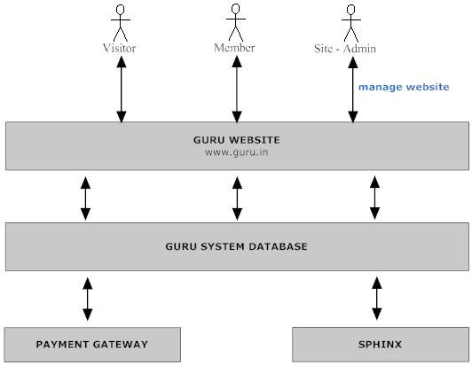

1.4 Reference
SRS document

1.5 Definition and Abbreviation

OVERALL DESCRIPTION

2.1 Other Software Feature List

- Paypal Pro/Paypal IPN will be used for safe transaction.
- Sphinx

2.2 Platform & Technology

This software will be developed in PHP

• MySQL Server
• PHP MVC Framework (CI)
- JQuery
- Macromedia Dreamweaver 8

Jquery will be used to provide browser compatible rich client side scripting. All time critical SQL query will be implemented in the store procedure level.

2.3 Third Party Dependency

Jquery Modules.

2.4 R&D Scope

Sphinx.

SPECIFIC REQUIREMENTS

3.1 Software Interface Definition

Refer to SRS.

3.2 Other Software Features

Payment Gateway Integration

Paypal Pro/Paypal IPN will be used for safe transactio

Sphinx

.

ER DIAGRAMS

#1.0 User profile
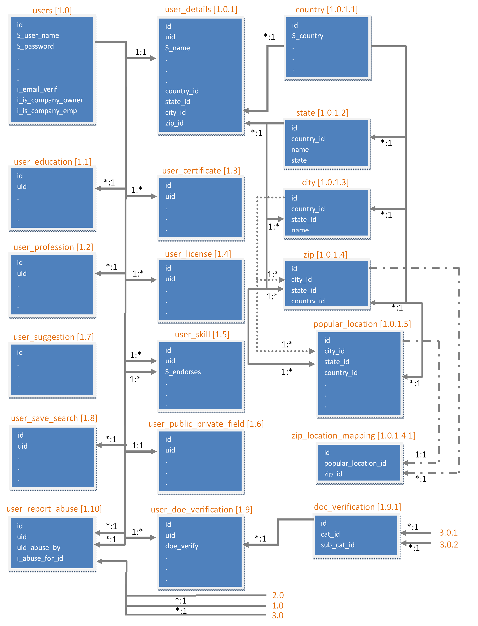

#2.0 Company profile
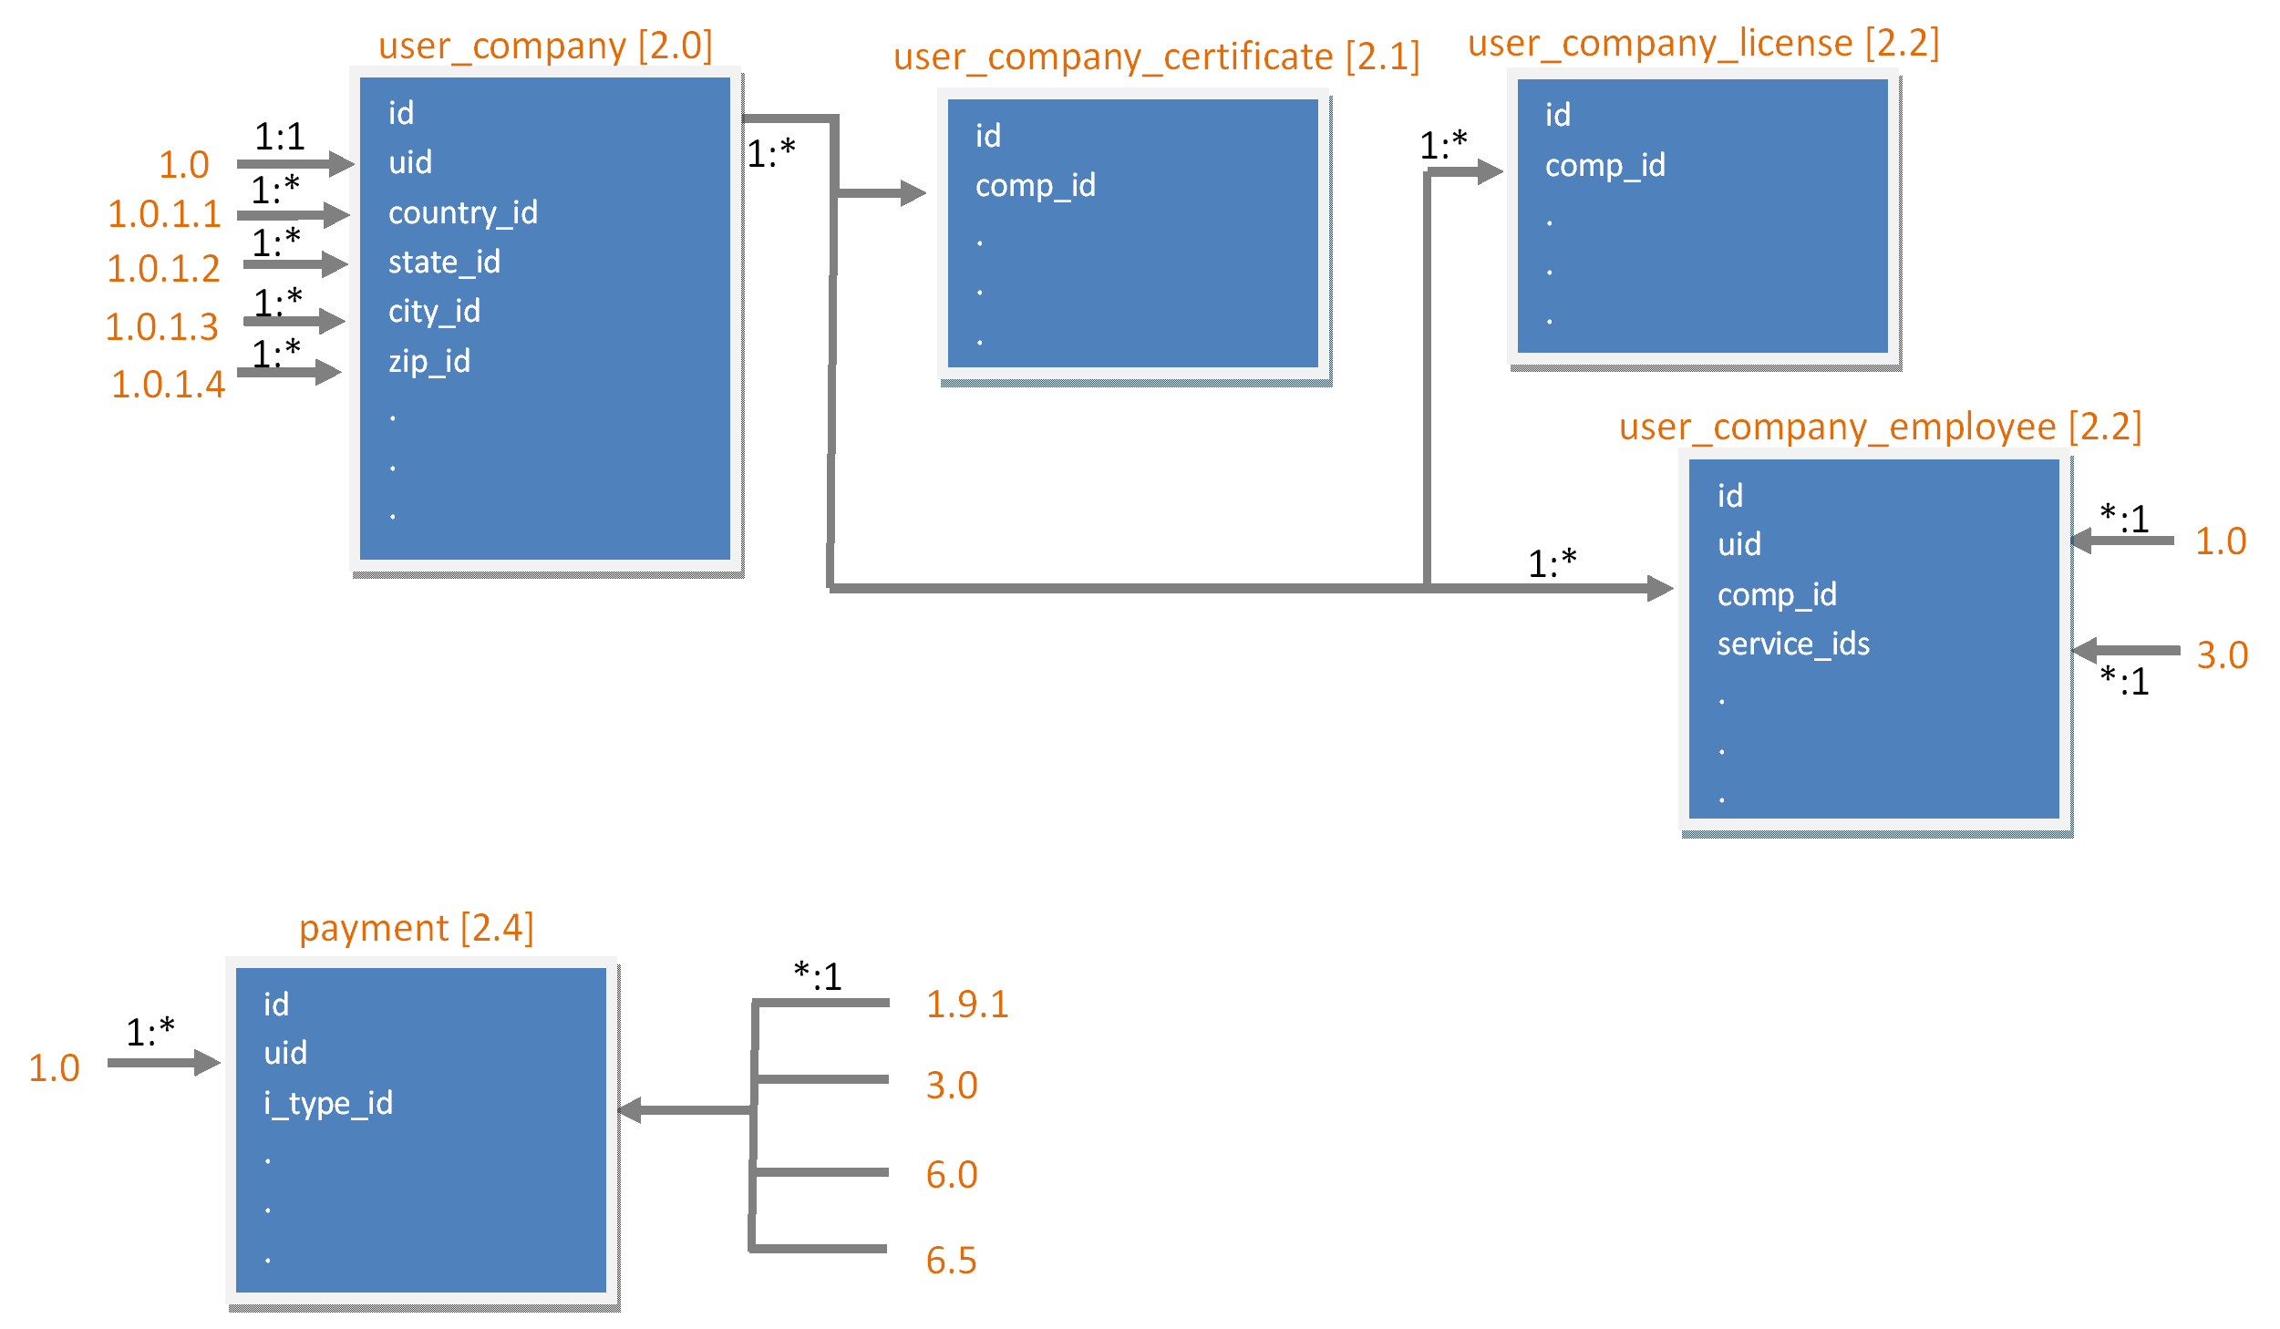

#3.0 User service

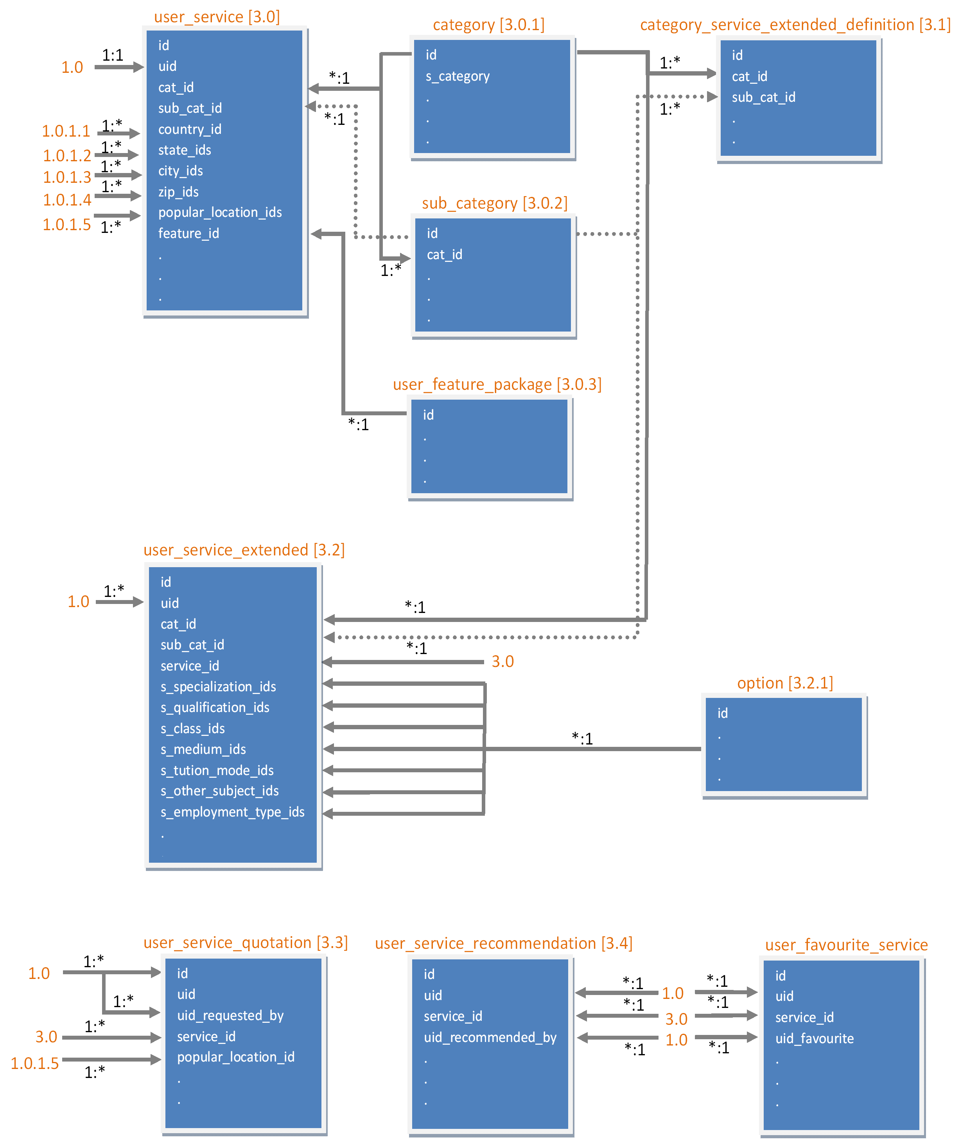

#4.0 Company service
No Entity identified, because it is a combination of all other services added by a Company.

#5.0 admin user
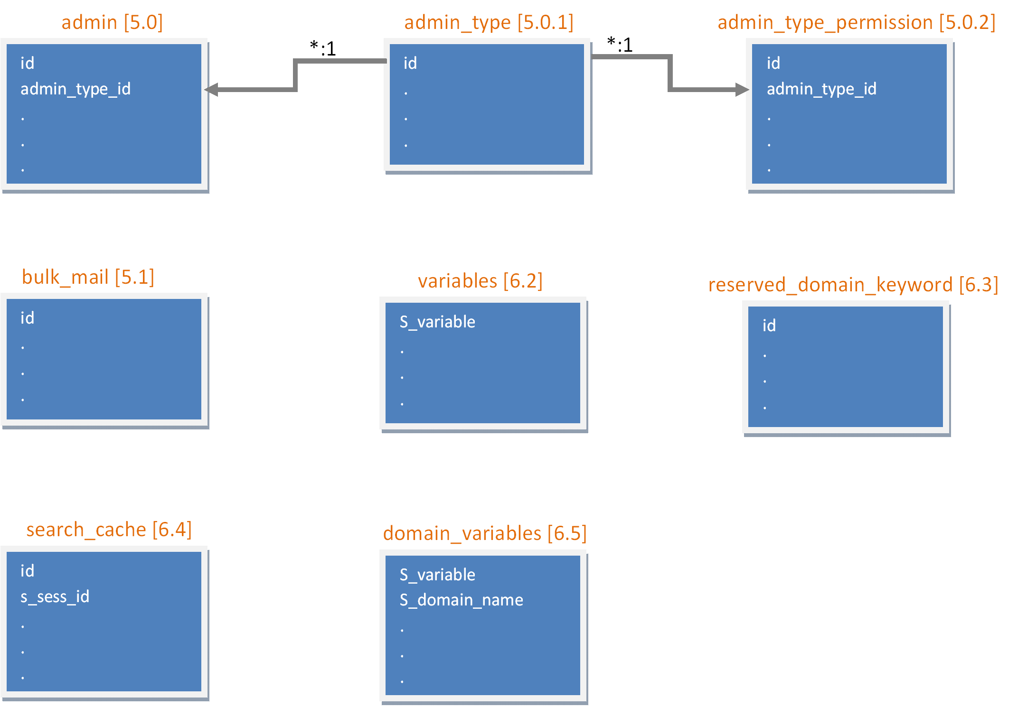

#6.0 Franchisee
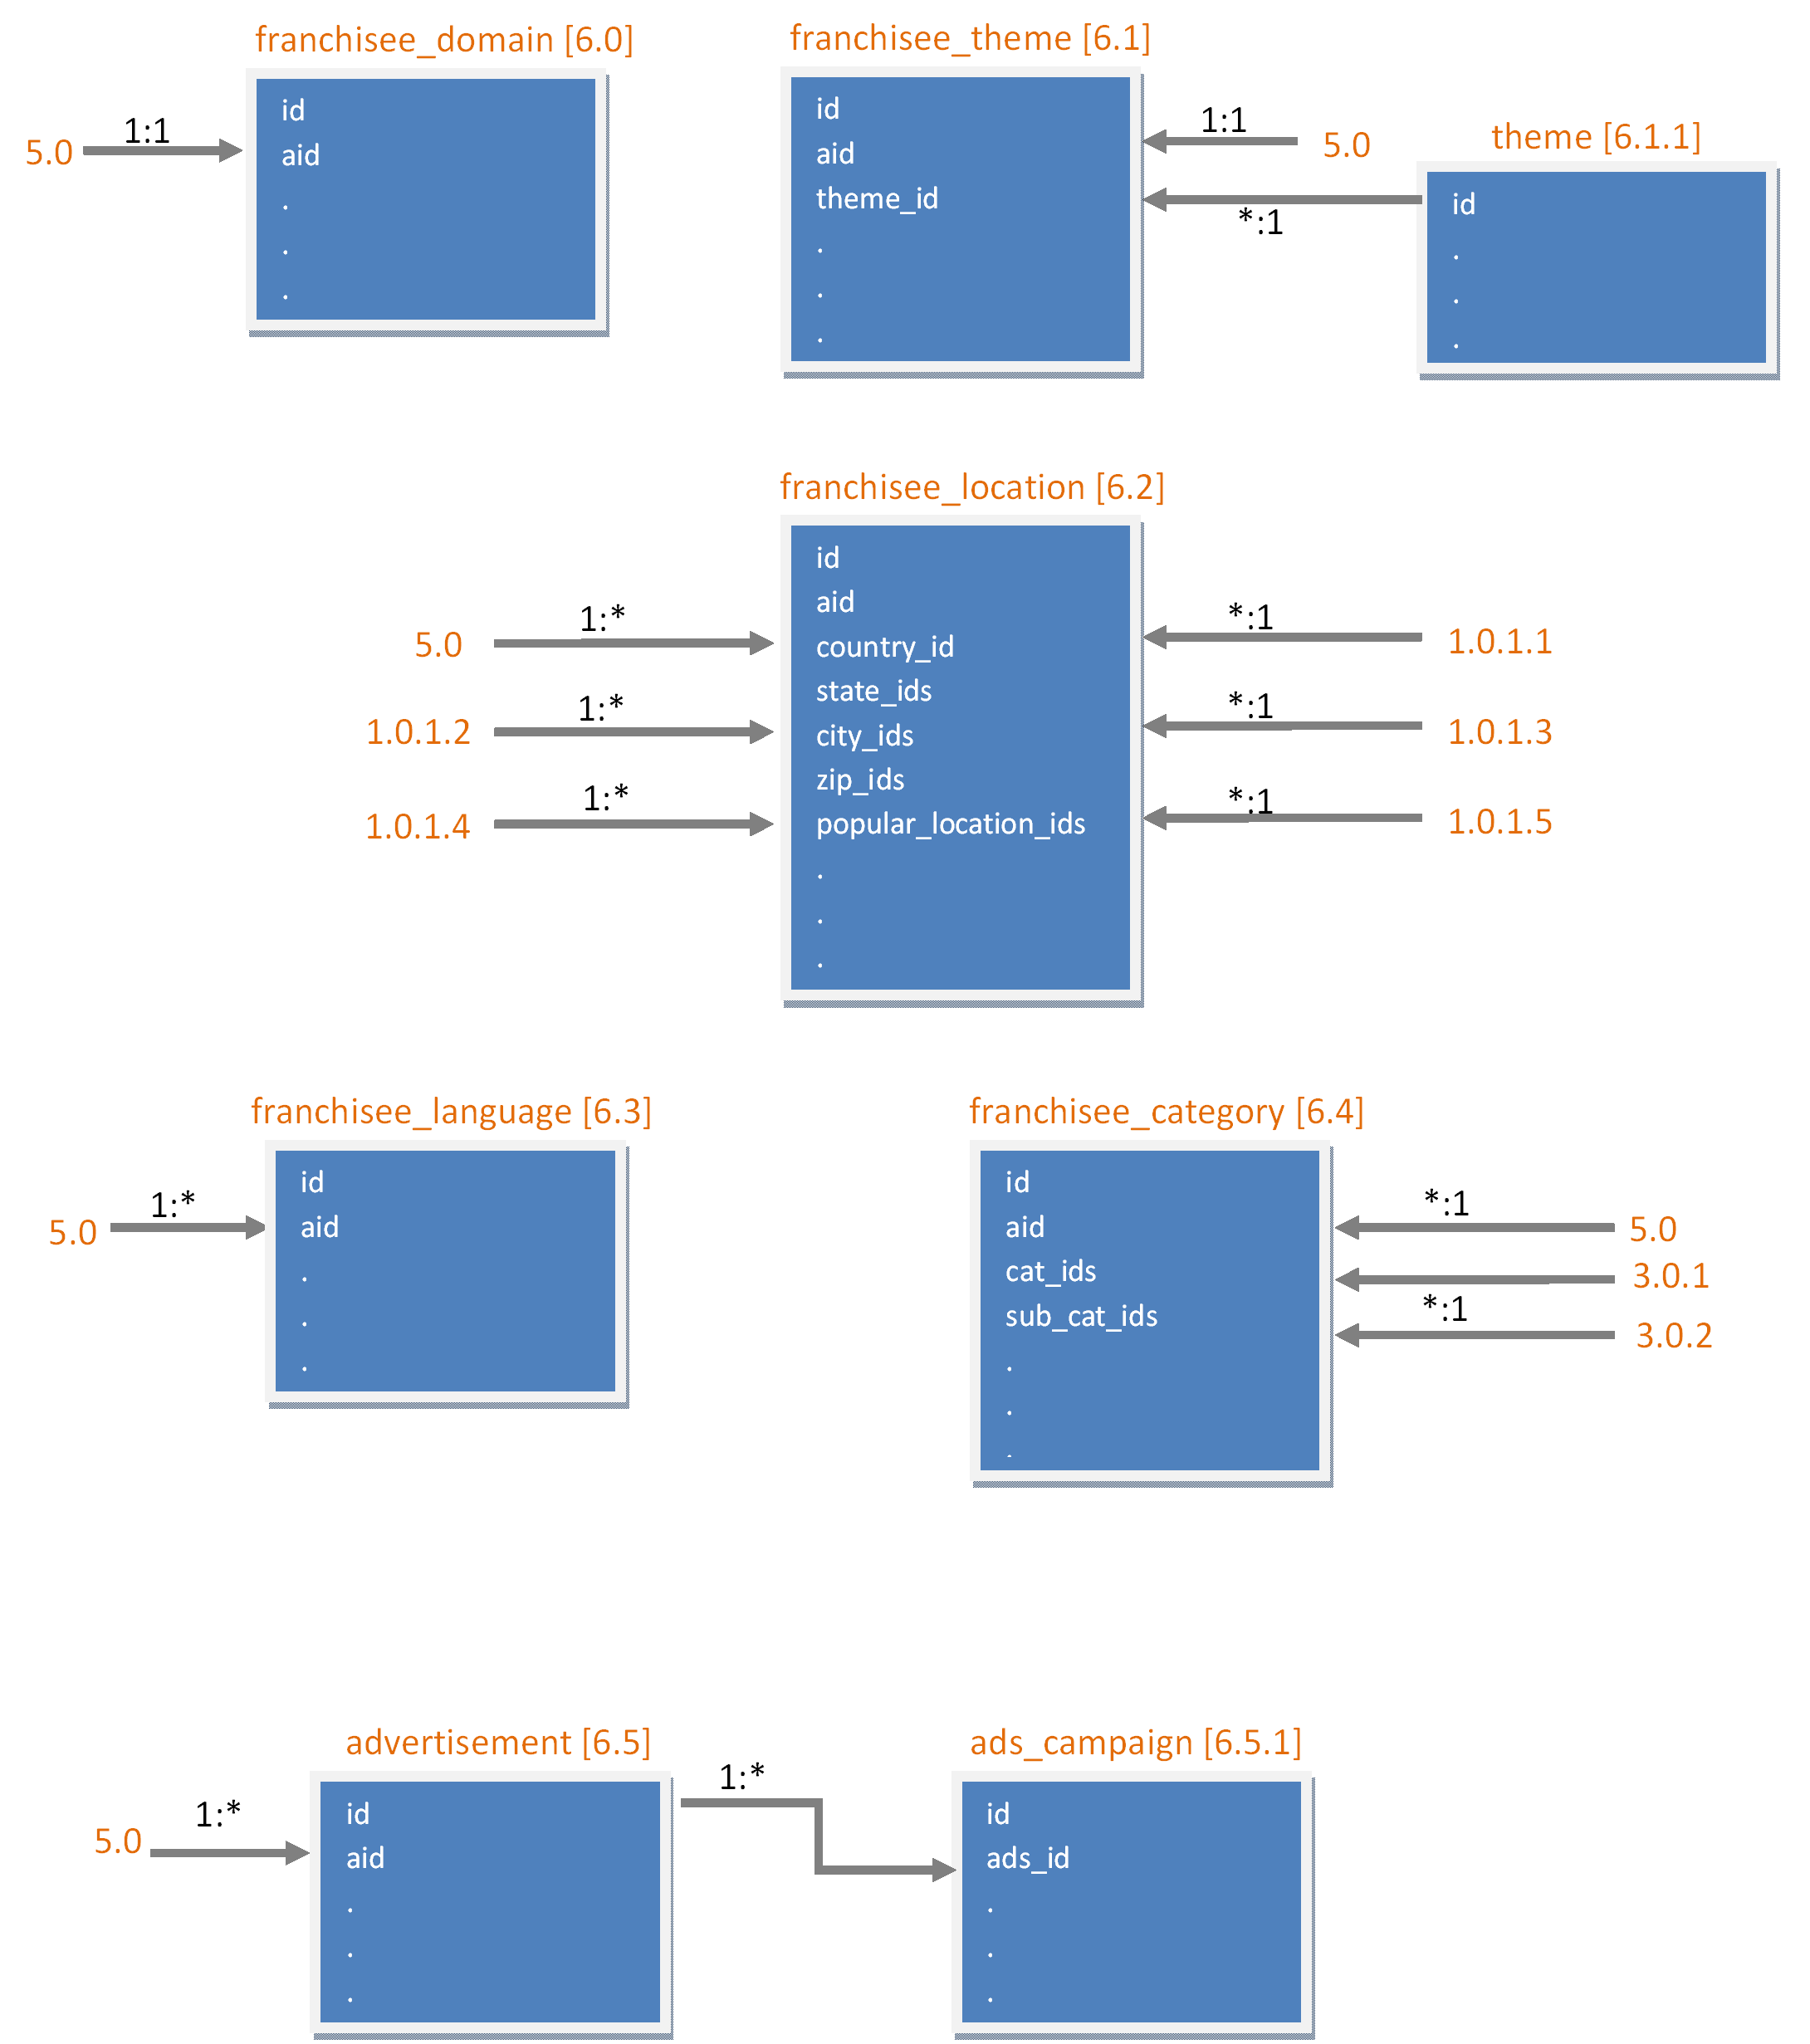

DATA STORAGE

admin_type
id
s_type
s_desc

admin_type_permission
id
admin_type_id
s_permission_name

admin
id
admin_type_id
s_admin_name
s_password(md5)
dt_last_login
dt_registration
s_ip
s_domain_name

category
id
s_category
s_desc
s_alias_names

sub_category
id
cat_id
s_sub_category
s_desc
s_alias_names

country
id
s_country

state
id
country_id
s_state

city
id
country_id
state_id
s_city
s_latitude
s_longitude

zip
id
city_id
state_id
country_id
s_zip
s_latitude
s_longitude

popular_location
id
city_id
state_id
country_id
s_location
s_latitude
s_longitude

zip_location_mapping
id
popular_location_id
zip_id

option
id
s_suggestion
e_type

doc_verification
id
s_document_required
cat_id
sub_cat_id
i_active

theme
id
s_theme
s_layout_php
i_active

bulk_mail
id
s_mail_to
s_mail_from
s_mail_body
i_send

variables
s_variable
s_value

cms
id
s_menu
s_content
s_url

reserved_domain_keyword
id
s_keyword

search_cache
id
s_sess_id
s_search_field_value
s_search_result
i_page_number
dt_cache_time

users
id
s_user_name
s_password(md5)
dt_last_login
dt_registration
s_ip
s_verification_code
e_status
i_email_verified
i_doc_verified
i_mobile_verified
s_mobile
s_mobile_verify_code
s_domain_name
s_facebook_credential
s_linkedin_credential
s_dummy
i_is_company_owner
i_is_company_emp

user_details
id
uid
s_name
s_email
s_phone
s_mobile
s_display_name
s_profile_photo
country_id
state_id
city_id
zip_id
dt_dob
i_age
e_gender
s_about_me
s_languages

user_education
id
uid
s_instutite
s_degree
s_specilization
s_desc
dt_from
dt_to

user_profession
id
uid
s_company
s_title
s_job_desc
s_location
dt_from
dt_to
i_currently_working

user_certificate
id
uid
s_certificate_name
s_desc
s_code
s_certified_from
dt_from
dt_to

user_license
i_id
uid
s_license_name
s_desc
s_code
s_licensed_from
dt_from
dt_to

user_skill
id
uid
s_skill_name
s_endorses
i_endorse_count

user_public_private_field
id
uid
i_gender
i_dob
i_location
i_language
i_about
i_educational
i_professional
i_certificate
i_license
i_photo
i_email
i_phone_number
i_mobile_number

user_service
id
uid
cat_id
sub_cat_id
s_service_name
s_service_desc
country_id
state_ids
city_ids
zip_ids
popular_location_ids
s_skype
s_yahoo
s_gtalk
i_online
s_suggested_medium
s_languages
i_profile_complete_percent
dt_created
i_active
i_featured
dt_featured_expiry
feature_id
s_dummy
i_view_count
i_is_company_default

category_service_extended_defination
id
cat_id
sub_cat_id
s_column_name
dt_insert_time
s_search_page_label
e_search_page_input
s_search_page_default_value
s_search_page_options
s_search_page_order
s_service_page_label
e_service_page_input
s_service_page_default_value
s_service_page_options
s_service_page_order

user_service_extended
id
uid
cat_id
sub_cat_id
service_id
s_specialization_ids
s_qualification_ids
d_experience
s_classes_ids
s_medium_ids
d_tution_fee
s_tution_mode_ids
s_other_subject_ids
d_rate
s_employment_type_id

user_service_quotation
id
uid
s_message_thread
uid_requested_by
service_id
dt_service_start
popular_location_id
s_visitor_email
e_status

user_service_recommendation
id
uid
service_id
s_message
uid_recommended_by
e_status

user_favourite_sevice
id
uid
service_id
s_message
uid_favourite

user_feature_package
id
s_package_name
s_desc
i_months_validity
i_price
i_active

user_suggestion
id
s_suggestion
e_type

user_save_search
id
uid
s_search_tag
s_search_field_value
s_url

user_report_abuse
id
uid
s_report
uid_abuse_by
e_absue_for
i_absue_for_id
e_action_taken

user_feedback
id
uid
s_message
uid_feedback_by

user_reference
id
uid
s_message
uid_referred_by

user_like
id
uid
s_message
uid_liked_by

user_doc_verification
id
uid
doc_verify_id
i_verified

user_company
id
uid
s_company
s_about_company
s_email
s_phone
s_mobile
country_id
state_id
city_id
zip_id
s_logo
s_links
s_blog_url
i_active

user_company_certificate
id
comp_id
s_certificate_name
s_desc
s_code
s_certified_from

user_company_license
id
comp_id
s_license_name
s_desc
s_code
s_licensed_from

user_company_employee
id
uid
comp_id
service_ids
e_employee_role
i_active

franchisee_domain
id
aid
s_domain
s_sub_domain
s_url
s_site_name
s_desc
s_type_meta_keyword
s_facebook_api
s_linkedin_api
s_google_adword
s_google_analytics_api
s_google_webmaster_api
s_google_ads_sense_code
i_active

franchisee_theme
id
aid
theme_id
s_logo
s_layout_php
s_layout_php_previous
s_layout_php_default
i_active

franchisee_location
id
aid
country_id
state_ids
city_ids
zip_ids
popular_location_ids

franchisee_language
id
aid
s_languages

franchisee_category
id
aid
cat_ids
sub_cat_ids

advertisement
id
aid
s_image
s_desc
s_url
e_ads_type
dt_expire
d_cpc
d_cpm
i_displayed_count
i_active

ads_campaign
id
ads_id
s_ip
dt_visited

domain_variables
s_domain_name
s_variable
s_value

payment
id
uid
i_type_id
e_type
s_transaction
s_payment_mode
e_status

DATA FLOW DIAGRAMS

Front Interface Diagrams

Home Page

READ | user_service
READ | users
READ | popular_location
READ | zip
READ | country
READ | variables

HomePop-up

READ | users

Sign Up

WRITE | users

Login

READ | users

Login Recovery

READ/WRITE | users

Report Abuse

WRITE | user_report_abuse

Contact Us

Send Email

Start up Pages

Select a Service Type

WRITE | user_company

Make Service Featured

READ | user_service
READ | users
READ | user_company

Make Service Featured_2

WRITE | user_service
READ | user_feature_package
WRITE | payment

Start A Company

READ | user_company
READ | cms

Option for Profile Entry

READ/WRITE | users
READ/WRITE | user_details
READ/WRITE | user_education
READ/WRITE | user_profession
READ/WRITE | user_certificate
READ/WRITE | user_license
READ/WRITE | user_skill
READ/WRITE | user_public_private_field
READ/WRITE | user_service
READ/WRITE | user_service_extended

Demo edit mode

READ/WRITE | users
READ/WRITE | user_details
READ/WRITE | user_education
READ/WRITE | user_profession
READ/WRITE | user_certificate
READ/WRITE | user_license
READ/WRITE | user_skill
READ/WRITE | user_public_private_field
READ | user_service
READ | user_service_extended
WRITE | user_report_abuse

Add a service

READ | variables
WRITE | user_service
WRITE | user_service_extended
READ | category
READ | sub_category
READ | country
READ | city
READ | zip

Company Profile

Company Profile

READ | user_company
READ | user_company_certificate
READ | user_company_license
READ | user_company_employee
READ | users
READ | user_details
READ | user_service
WRITE | user_report_abuse

Company Profile After 1st time

Service Profile

Service Profile

READ | Users
READ | user_details
READ | user_education
READ | user_profession
READ | user_certificate
READ | user_license
READ | user_public_private_field
READ | user_service
READ | user_service_extended
READ | user_company
READ | user_company_certificate
READ | user_company_license
READ | user_company_employee
READ | user_service_recommendation
WRITE | user_service_quotation
WRITE | user_report_abuse

Service Profile edit

READ | users
READ/WRITE | user_details
READ/WRITE | user_education
READ | user_profession
READ/WRITE | user_certificate
READ/WRITE | user_license
READ | user_public_private_field
READ/WRITE | user_service
READ/WRITE | user_service_extended
READ/WRITE | user_company
READ/WRITE | user_company_certificate
READ/WRITE | user_company_license
READ | user_company_employee
WRITE | user_service_quotation
WRITE | user_report_abuse

Service Profile Entry 1st time

READ | users
READ/WRITE | user_details
READ/WRITE | user_education
READ | user_profession
READ/WRITE | user_certificate
READ/WRITE | user_license
READ | user_public_private_field
WRITE | user_service
WRITE | user_service_extended
READ/WRITE | user_company
WRITE | user_company_certificate
WRITE | user_company_license
WRITE | user_company_employee
WRITE | user_report_abuse

Recomendation

READ | user_service
WRITE | user_service_recommendation

User Profile

User Profile

READ | users
READ | user_details
READ | user_education
READ | user_profession
READ | user_certificate
READ | user_license
READ | user_public_private_field
READ | user_skill
WRITE | user_report_abuse

Ist Time User info entry

READ/WRITE | users
READ/WRITE | user_details
READ/WRITE | user_education
READ/WRITE | user_profession
READ/WRITE | user_certificate
READ/WRITE | user_license
READ/WRITE | user_public_private_field
READ/WRITE | user_skill
WRITE | user_report_abuse

User Profile edit

READ/WRITE | users
READ/WRITE | user_details
READ/WRITE | user_education
READ/WRITE | user_profession
READ/WRITE | user_certificate
READ/WRITE | user_license
READ/WRITE | user_public_private_field
READ/WRITE | user_skill
WRITE | user_report_abuse

Be A Franchisee

Domain and Sub Domain

WRITE | franchisee_domain
READ | reserved_domain_keyword
WRITE | admin

Select Location

WRITE | franchisee_location
READ | admin

Select Category

WRITE | franchisee_category
READ | admin

Select Language

WRITE | franchisee_language
READ | admin
WRITE | user_suggestion

Upload Logo

WRITE | franchisee_theme
READ | admin

Select Theme

WRITE | franchisee_theme
READ | admin

Site Management

WRITE | franchisee_domain
READ | admin
READ/WRITE | domain_variables

Listing Profile

Listing for Designer

READ | users
READ | user_details
READ | user_public_private_field
READ | user_service
READ | user_service_extended
READ | user_company
READ | user_company_employee
WRITE | user_service_recommendation
READ/WRITE | user_skill
WRITE | user_report_abuse
READ/WRITE | user_save_search
READ/WRITE | search_cache

Listing For Dentist

READ | users
READ | user_details
READ | user_public_private_field
READ | user_service
READ | user_service_extended
READ | user_company
READ | user_company_employee
WRITE | user_service_recommendation
READ/WRITE | user_skill
WRITE | user_report_abuse
READ/WRITE | user_save_search
READ/WRITE | search_cache

Listing for Tutor

READ | users
READ | user_details
READ | user_public_private_field
READ | user_service
READ | user_service_extended
READ | user_company
READ | user_company_employee
WRITE | user_service_recommendation
READ/WRITE | user_skill
WRITE | user_report_abuse
READ/WRITE | user_save_search
READ/WRITE | search_cache

Listing for Maths tutor OR IN CASE OF SPECIALIZATION

READ | users
READ | user_details
READ | user_public_private_field
READ | user_service
READ | user_service_extended
READ | user_company
READ | user_company_employee
WRITE | user_service_recommendation
READ/WRITE | user_skill
WRITE | user_report_abuse
READ/WRITE | user_save_search
READ/WRITE | search_cache

Listing for US tutor

READ | users
READ | user_details
READ | user_public_private_field
READ | user_service
READ | user_service_extended
READ | user_company
READ | user_company_employee
WRITE | user_service_recommendation
READ/WRITE | user_skill
WRITE | user_report_abuse
READ/WRITE | user_save_search
READ/WRITE | search_cache

Listing for the keyword math

READ | users
READ | user_details
READ | user_public_private_field
READ | user_service
READ | user_service_extended
READ | user_company
READ | user_company_employee
WRITE | user_service_recommendation
READ/WRITE | user_skill
WRITE | user_report_abuse
READ/WRITE | user_save_search
READ/WRITE | search_cache

Dashboard

Dashboard

READ | users
READ | user_details
READ | user_skill
READ | user_service_recommendation
READ | user_service

Inbox

Favourite

READ | users
READ | user_details
READ/WRITE | user_favourite_sevice
READ | user_service

Save Search

READ | users
READ | user_details
READ | user_service
READ/WRITE | user_save_search

Endorsement

READ | users
READ | user_details
READ | user_service
READ/WRITE | user_skill

Manage Recommendation

READ | users
READ | user_details
READ | user_service
READ/WRITE | user_service_recommendation

Employee List

READ/WRITE | users
READ/WRITE | user_details
READ | user_service
READ | user_company
READ/WRITE | user_company_employee

